Repacking Hubs
This document was constructed from:
http://www.waltermotorsports.com/v/Racing/hub/

This series of photos will show how to repack the front hubs from a miata.
Tools:
Rubber mallet or Deadblow hammer
Small screwdriver
Redline CV-2 grease
Two containers (to hold the inner and outer bearings)
wd-40 (cleaning and storage)
29mm socket
20mm socket
4 small washers
Toothbrush
Rags
I am blatantly stealing the text from Karl Zimmerman's writeup. If re-packing your own hubs seems like too much, he sells repacked hubs from his sitewww.appliedracingtechnology.com

New Hub  This is a brand spanking new hub fresh out of the box. | 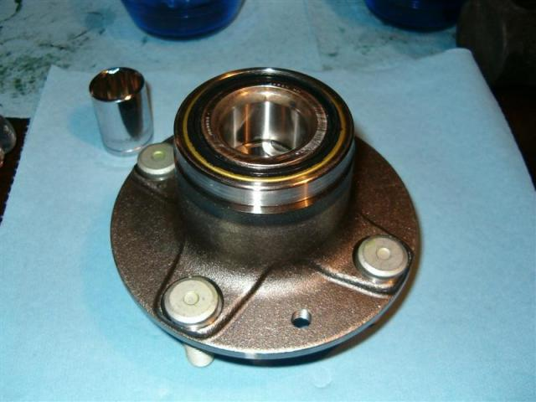
Insert Washers  Insert four small washers in the gap between the front and back inner races | 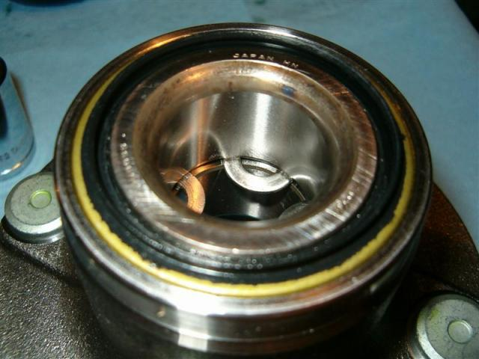
All 4 Washers  From this angle you can see all four washers.  I'm sure that 2 washers would be enough to prevent damager, but I'm paranoid and it isn't any harder to insert all 4. | 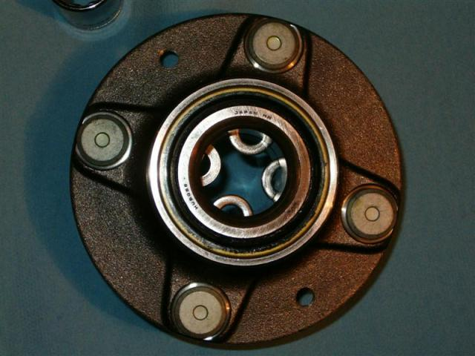
Tap Front Race Out  Insert the 20mm socket so it rests on the washers.  If the socket is too short, use a short extension.  Tap the socket lightly to force the race out the front of the hub.  Resting the hub on the studs makes it easy. | 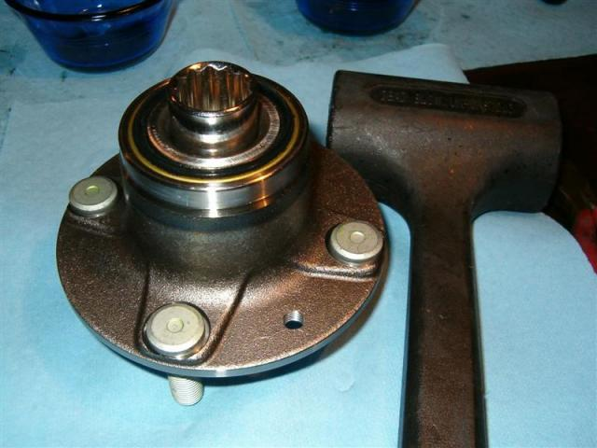
Ball Bearings  Once the front inner race is out, you can see the BBs and the plastic holder.  Note how the holder supports the BBs. | 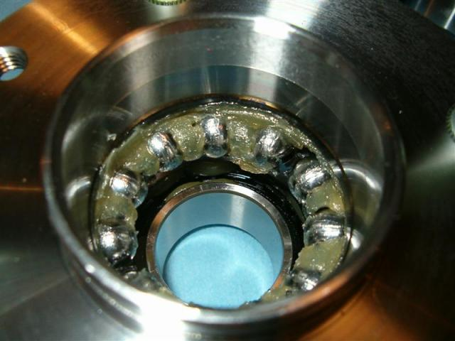
Pop Front BBs Out  Take the small screwdriver and pop out the BBs from the holder.  Don't worry too much about the holder, it's fairly resiliant and can take some stretching. BUT, don't break it or you'll be out one hub.  Put the BBs into a cup filled with some WD40.  Take the holder out of the hub. It will have to squish a little, but again, don't worry about it. | 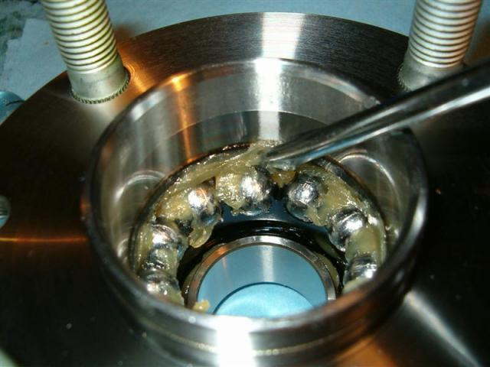
Tap Back Race Out  Hold the hub in your left hand (right if you are a south-paw) and place the 29mm into the hub. I found if you put the socket in like shown, the flat end of the socket sits on the race's lip and you drive it more straight.  Put an extension backwards into the socket if it isn't tall enough. | 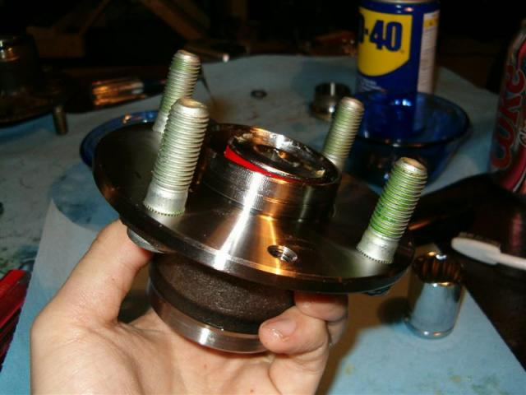
Pop Back BBs Out  Same procedure as the front BBs; pop em out with the small screwdriver being careful not to scratch the out race.  This plastic holder is slightly different than the front holder, so save yourself some confusion and keep them seperate. | 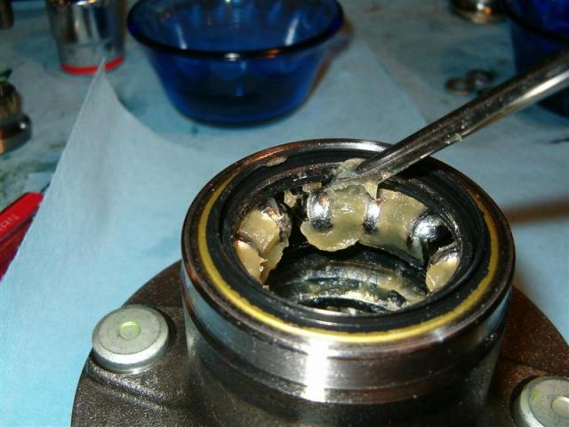
Pull the Holder out of theHub  I pull the holder out the front of the hub.  You can leave it in and wait till you pop the seal out.  It'll squish a little. | 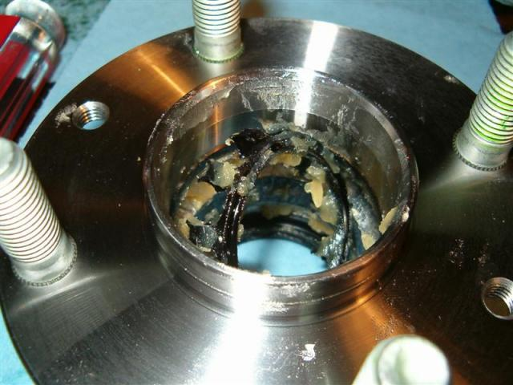
Front BBs, Holder and Race  Just a quick pic of the front stuff that came out of the hub.  Yeah...that's a glass ramikin. So what? I'm not married and it was all I had. Stop laughing. | 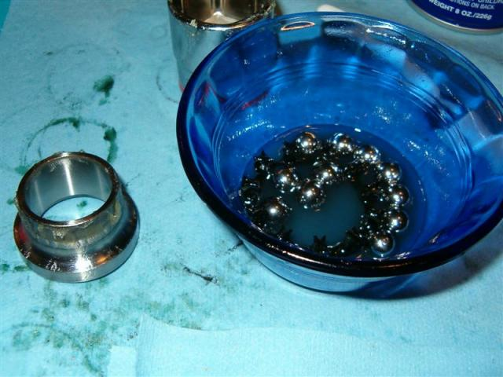
Pop Out Rear Seal  Put a screwdriver through the hub into the seal.  GENTLY tap the seal out by holding the screwdriver and hub and TAP (not slam) down.  Work around the seal slowly. It may not feel like you're doing any good, but give it a bit and it will come out.  Once the seal loosens, it goes quick, so don't drop the hub on your hand. | 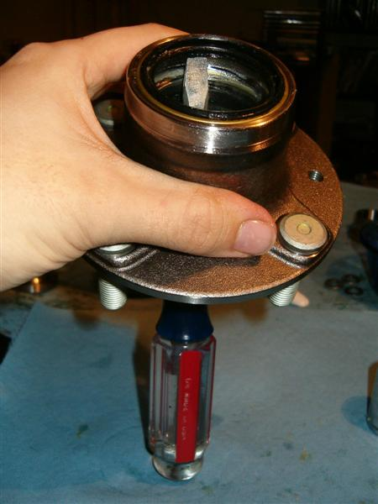
Shiny Hub  Take your toothbrush, rags and WD40 and clean away.  Clean the hub, BBs, races, holders and the seal.  Carefull with the seal though, there is a small spring retainer in there.  Some people have used LOW PRESSURE compressed air on the seal with good results. | 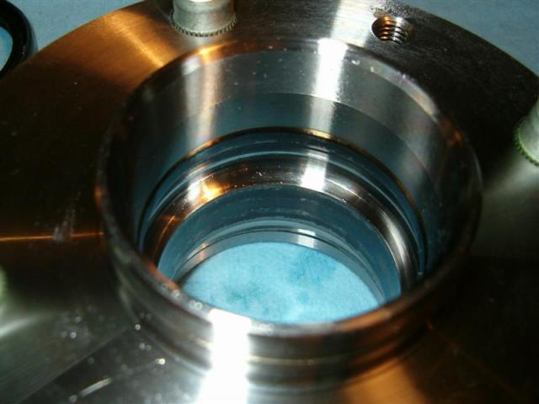
Load Back BBs  The back BB holder can actually hold all the BBs in place.  Load it up, pack some CV2 and drop it into the hub. | 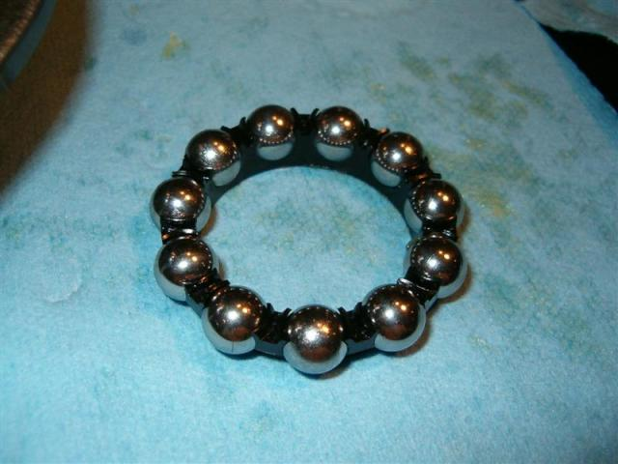
Pack Back BBs and Holder  I always use too much grease. Again, I'm paranoid.  You might want to be careful if you overload it, some excess grease can fling out of the hub and onto the suspension. | 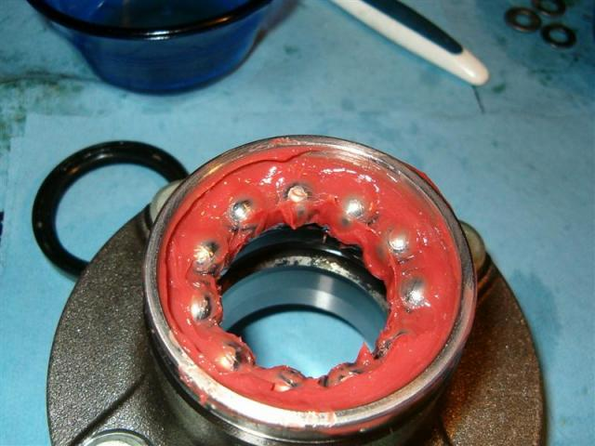
Place Back Race  Place the back race onto the BBs and gently tap into place. | 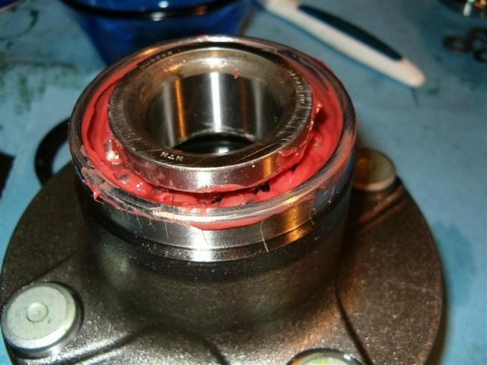
Back Race Seated  The race is seated into the hub. | 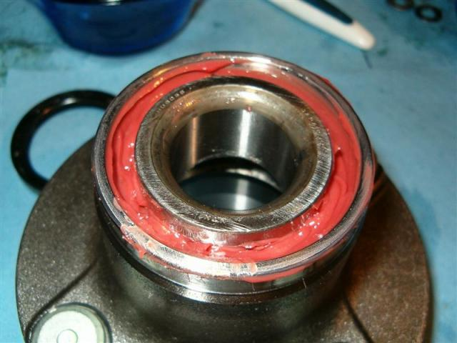
Front BBs into Holder  Slot the holder into the front.  I found the insert BBs on four corners will help prevent the holder from sliding down. | 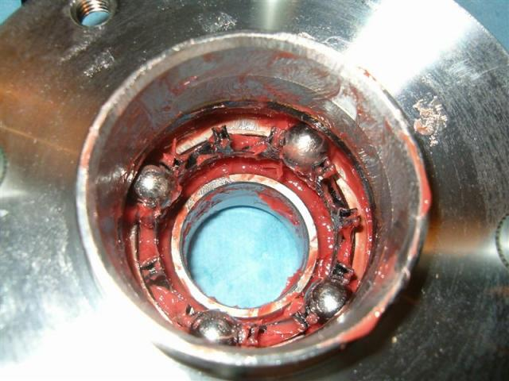
Holding BBs in Place  You will be frustrated the first few times, trying to get all the BBs in.  Stick your finger through the hub and wedge the holder in place while you push the next BB into the holder.  Push the holder forward while you push the BB in. It gets easier the more BBs are placed into the holder.  btw, this is an old hub. Notice the metal lip formed into the hub above the BBs. New hubs don't have this. (more on that later) | 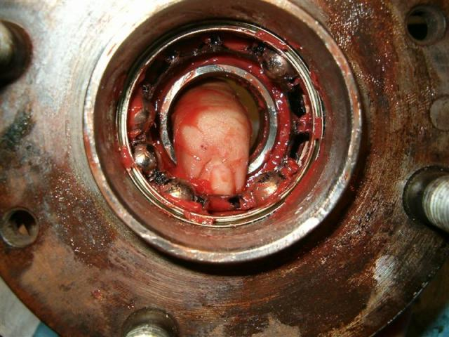
Front Race Install  Drop the front inner race in and tap it into place with the socket and mallet. | 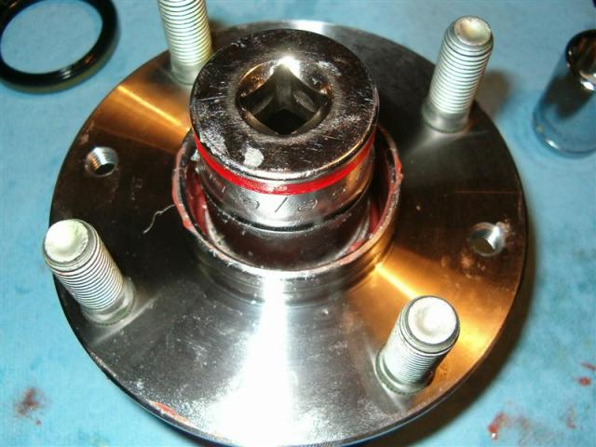
Front Race in Place  Tapped in and greased up.  Clean up the excess grease, of course. | 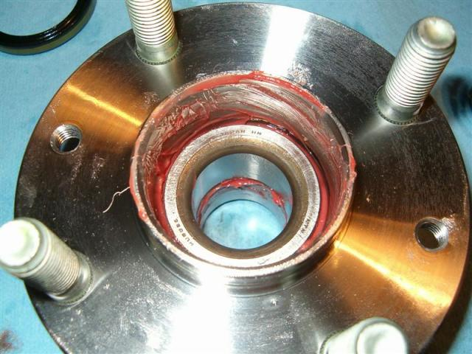
Place Seal  Gently push the seal into the hub by hand.  NOTICE: One side/face of the seal is entirely rubber and the other has some metal showing. Insert the seal with the metal SHOWING. | 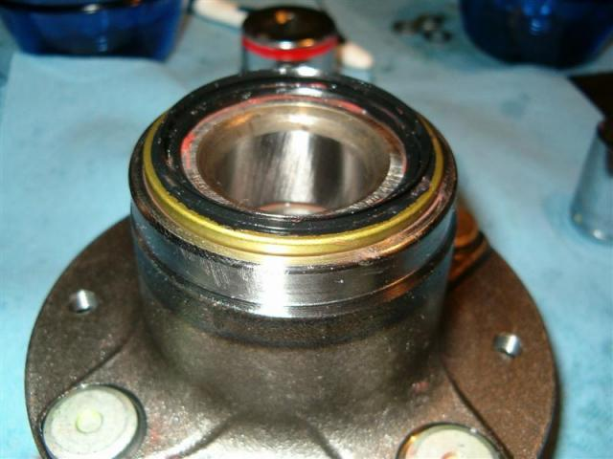
Seal Tapped In  Tap the seal in gently.  You don't want to mangle it now after all that work. | 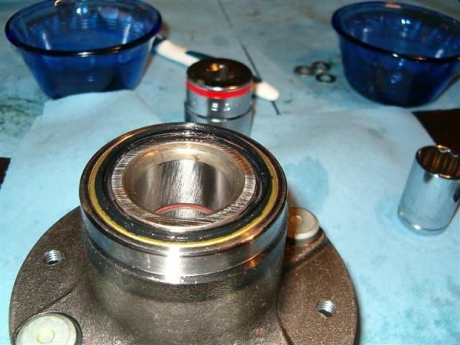
Old Style Hub  Remember that weird metal seal?  Well, you can see it better here.  I'm not sure if it really helps, but it does make pulling the holders out of the hub a little harder.  Did you notice the green grease? I pulled them off a donor miata. They had no metal in the grease, and no metal fatigue at all. I kinda felt bad pulling it apart, it looked practically brand new. | 